**Add immediate alert service at the client side**

1. add header file:



2. define service:



3. add in db discovery handler function:

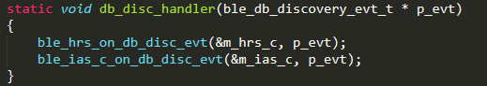

4. initial ias client:

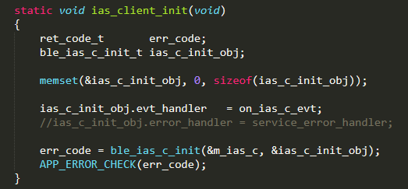

5. define ias event handler:

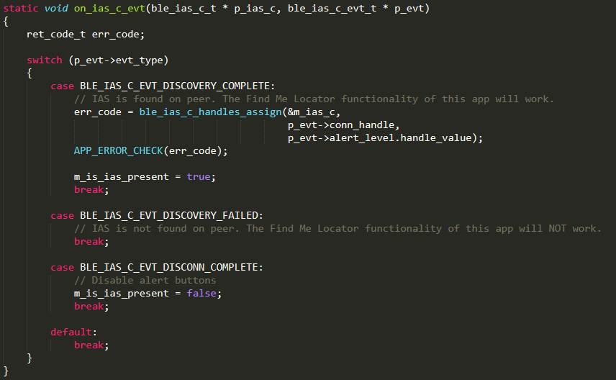

Simpler than other services(heart rate or battery)

6. update alert level:

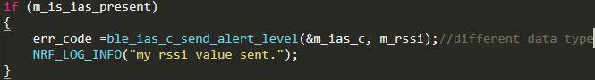

Can be placed in wherever you want.

**Add immediate alert service at the server side**

1. add header file:



2. define ias service:



3. initial the ias service:

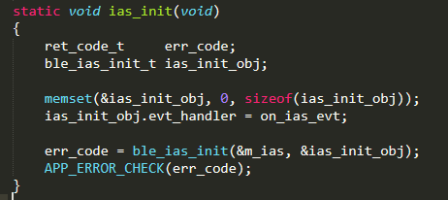

4. add the definition of the ias event handler:

